Ordering Instructions for Stationery Products
There are a few customers that are still granted access directly to the Print Acquisition website to order stationery. All other departments must log into Aggie Buy to purchase stationery products. The only other exception are “special order” stationery products. These “special orders” consist of information granted by departments that will not fit on the formatted templates.
Follow these instructions to place orders through the Aggie Buy punch out:
- Log on to Aggie Buy through Single Sign On: https://sso.tamus.edu
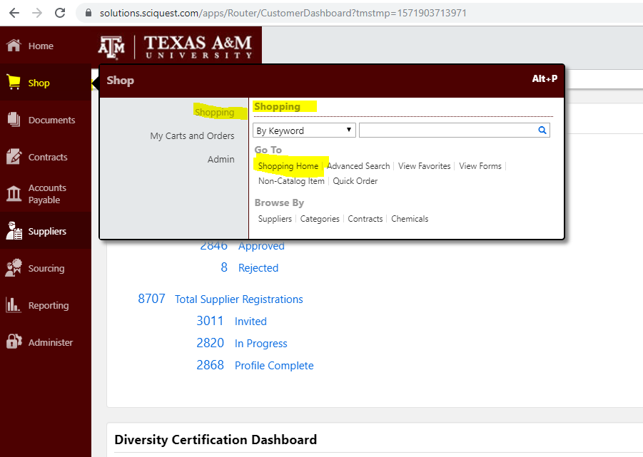
- Go to the Shopping Home page

- Click on the TAMU Print AlphaGraphics icon
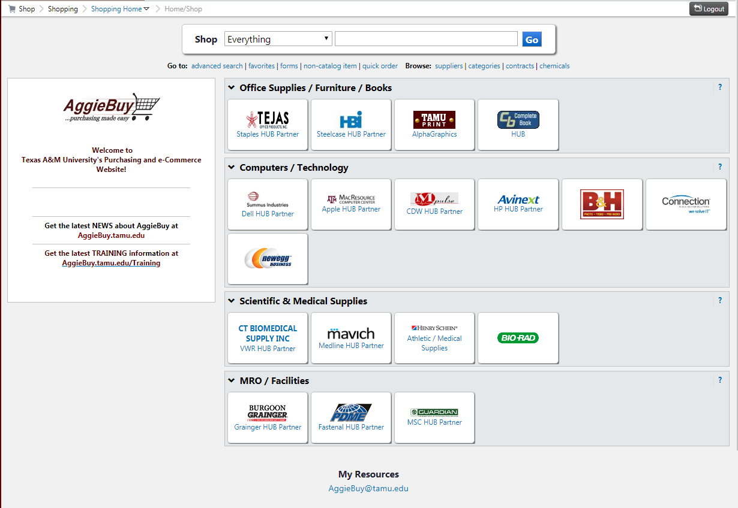

- A new page should open to the Print Acquisition site.
If the page does not open, check your pop blocker to make sure it shows “Allowed” for this site.
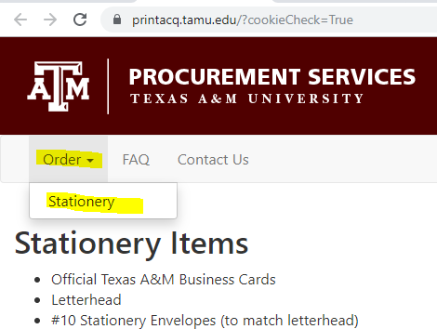
- In the top left hand corner click on Order then Stationery

- Click on your organization:
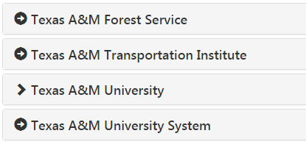
- If you are under Texas A&M University click on Colleges or Office/Divisions
Each will expand to reveal all of the colleges, offices or divisions within Texas A&M University.
- Click on your college/office/division

- Choose the stationery piece you are ordering and follow the on screen prompts.

- After filling in the required fields, you will get a PDF image – this is your proof. Review it carefully as this is exactly how your product will be printed. The vendor does not check for errors or misspellings as it goes directly to print after the order is placed.
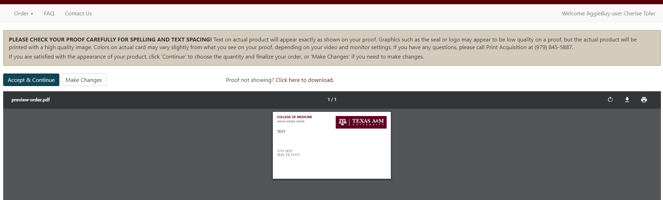
Suggestion: Print the pdf that is provided in the system and keep it for your files. If there is an error somewhere later in the process this pdf will be helpful in determining where the error occurred. It can also serve as a future template for other orders.

IMPORTANT FOR ALL TYPES OF ORDERS: YOU MUST PROVIDE FULL CONTACT INFORMATION IN CASE THE PRINTER NEEDS TO CONTACT YOU WITH QUESTIONS OR CONCERNS.

TEXAS A&M FOREST SERVICE HAS DIRECT ACCESS TO THE PRINT ACQUISITION WEBSITE. ALL OTHER USERS MUST LOG INTO AGGIE BUY TO ORDER STATIONERY PRODUCTS.

